Procedure

1. download archetype maven-archetype-webapp

mvn archetype:generate -DgroupId=com.capg.webapp -DartifactId=capgfin-Project -DarchetypeArtifactId=maven-archetype-webapp -DinteractiveMode=false

1. Update pom.xml code to add maven plugin to copy artifacts onto tomcat this should be under

<plugins>

<plugin>

<groupId>org.apache.tomcat.maven</groupId>

<artifactId>tomcat7-maven-plugin</artifactId>

<version>2.2</version>

<configuration>

<url>http://localhost:8080/manager/text</url>

<server>TomcatServer</server>

<path>/helloworld-webapp</path>

</configuration>

</plugin>

</plugins>

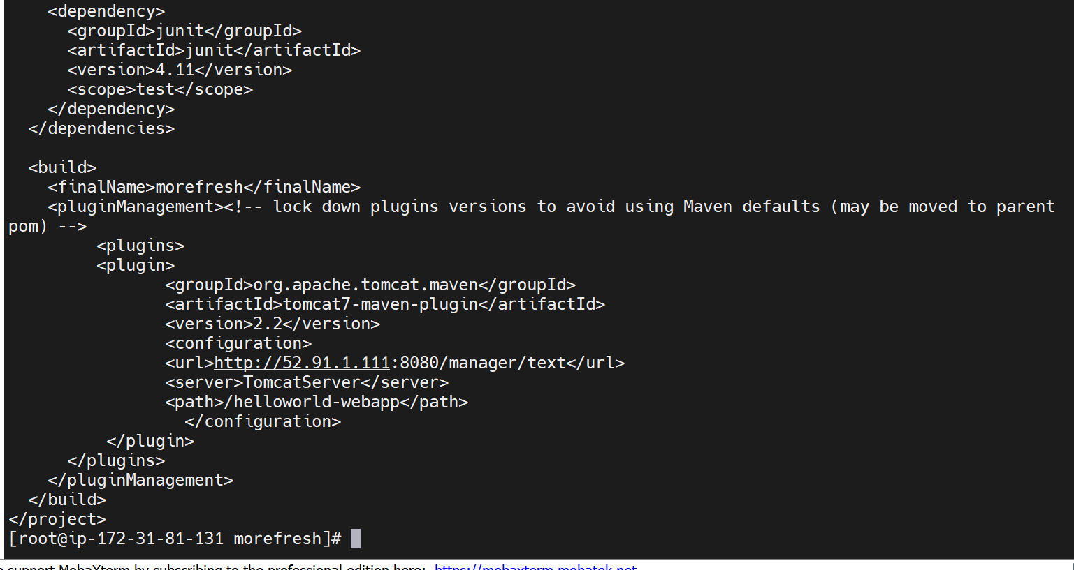

3. create settings.xml for credentials

<?xml version="1.0" encoding="UTF-8"?>

<settings ...>

<servers>

<server>

<id>TomcatServer</id>

<username>admin</username>

<password>admin</password>

</server>

</servers>

</settings>

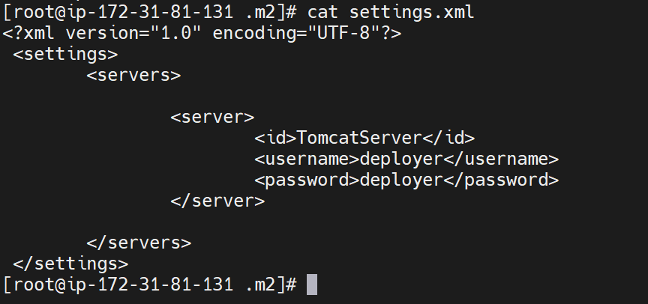

4. Build and the project on tomcat

sh

mvn tomcat7:deploy